Veterans Brotherhood
Massachusetts Chapter
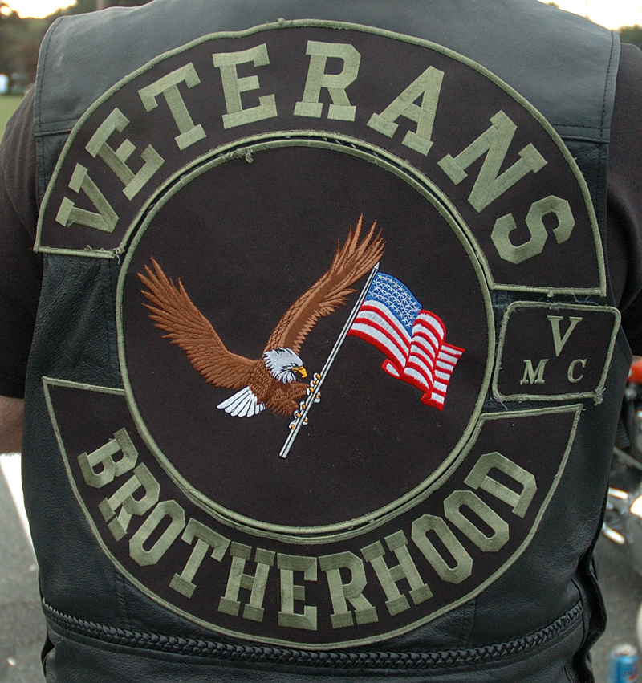

Application for Membership
Veterans Brotherhood Veterans Motorcycle Club

(Do not sign this application until you have read our Bylaws and
The VBVMC National Constitution and until you are prepared to
adhere to the VBVMC Code of Ethics and accept the concept of
Veterans Brotherhood to its fullest extent)

Name: __________________________________________________________________________________

Address: ___________________________________________ Home Phone: ______________________

City: _________________________________________________ State: _________ Zip: _____________

Employed By: ___________________________________________________________________________

Address: ___________________________________________ City: ______________________________

State: ____________ Zip: ____________________

Emergency Contact Person: _______________________________________________________________

Relationship: ____________________________________________________________________________

Telephone: ______________________________________________________________________________

Branch of Service: ________________________________________ Years Served: _________________

Unit: ___________________________________________________________________________________

Tactical Area of Operations: ______________________________________________

Road Name (Choose one, or have it chosen for you!):

______________________________________________

Motorcycle Information:

Make: ___________________________ Model: ___________________________

Size (cu inch) ________________________ (cc) _______________________

I, ____________________________________ have reviewed a copy of the bylaws

of the Veterans Brotherhood VMC on _____________________________________

I understand them and will abide by them.

Signature: ____________________________________________________________

Date: ________________________________________________________

(Submit with a copy of your DD-214)

Part #2

I acknowledge receipt of my "Colors" from the VBVMC.
I understand that the VBVMC Patch is organization property and is to be
kept presentable at all times.
By wearing the "Colors", I represent our Brotherhood.
I will conduct myself honorably and ethically in all matters pertaining to Club
Business, according to the mission of the Brotherhood.

Name: ________________________________________________________________

Signature: _____________________________________________________________

Date: _________________________________________________________________

Chapter President: _____________________________________________________

State President: ________________________________________________________

